Marketing Funnel Basics, Metrics & Ratios – Answers

1. Marketing Funnel for Instagram
MARKETING FUNNEL (Instagram)
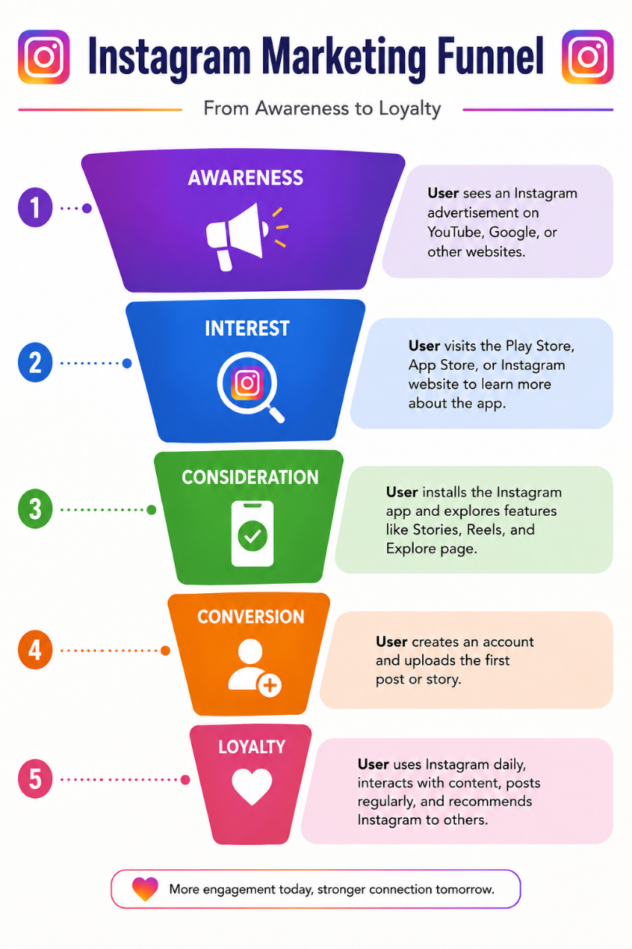
Funnel Stage | Real User Action
Awareness | Sees an Instagram advertisement on YouTube or Google
Interest | Visits the Play Store/App Store page
Consideration | Installs the app and explores its features
Conversion | Creates an account and uploads the first post
Loyalty | Uses Instagram daily and shares it with friends

2. Marketing Funnel Metrics Table for Flipkart
Funnel Stage | Metric 1 | Metric 2 | Metric 3
Awareness | Impressions | Reach | Website Visitors
Interest | Click-Through Rate (CTR) | Ad Clicks | Time on Website
Consideration | Product Views | Add to Cart | Wishlist Adds
Conversion | Purchases | Conversion Rate | Revenue
Loyalty | Repeat Orders | Customer Retention Rate | Customer Reviews

3. Conversion Rate Calculation
Given Data
- Ad Views = 10,000
- Clicks = 1,200
- App Installs = 300
- Orders = 60
Calculations
Ad View → Click
= (1,200 ÷ 10,000) × 100
= 12%

Click → App Install
= (300 ÷ 1,200) × 100
= 25%

App Install → Order
= (60 ÷ 300) × 100
= 20%

Overall Conversion (Ad View → Order)
= (60 ÷ 10,000) × 100
= 0.6%
Summary Table
Stage | Formula | Conversion Rate
Ad View → Click | 1,200 ÷ 10,000 × 100 | 12%
Click → Install | 300 ÷ 1,200 × 100 | 25%
Install → Order | 60 ÷ 300 × 100 | 20%
Overall (View → Order) | 60 ÷ 10,000 × 100 | 0.6%

4. Metric Explanation – Click-Through Rate (CTR)
Click-Through Rate (CTR) measures the percentage of people who click on an advertisement after seeing it.
A digital marketer for a music streaming app like Spotify can use CTR to understand whether the ad is attracting users. If the CTR is low, they can improve the ad by using better visuals, catchy headlines, or more relevant audience targeting to increase clicks and app installs.

